2018-2019 REQUIRED VALEO ACADEMY
GYM UNIFORM
3rd through 12th grades ONLY

Grey Gym T-Shirt $8.00 Each
Size | Quantity | Total Cost
Child’s Small (6-8)
Child’s Medium (10-12)
Child’s Large (14-16
Adult Small
Adult Medium
Adult Large
Adult XL
Adult 2XL (add $3.00 each)
Total
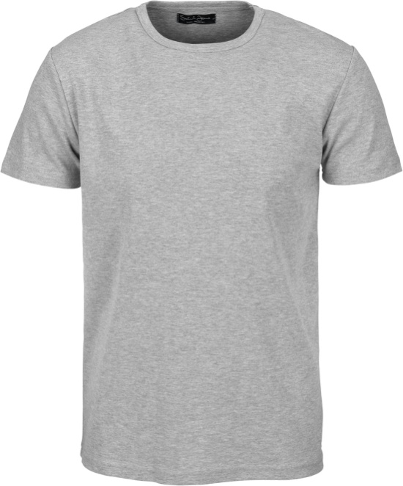
Grey T-shirt with VALEO ACADEMY printed in blue

Navy Blue Gym Shorts $9.00 Each
Size | Quantity | Total Cost
Child’s Small (6-8)
Child’s Medium (10-12)
Child’s Large (14-16
Adult Small
Adult Medium
Adult Large
Adult XL
Adult 2XL (add $2.00 each)
Total
Navy Blue Gym shorts with Valeo Academy printed in white

Name: ________________________________

Amount Paid___________Via____________

Cash or check accepted.

